Observations:

1. The name of signup button is not as per wireframe.
2. The color of login hyperlink is not in same color as per wireframe.
3. The visibility option is not visible as per wireframe.
4. Login and signup button are not visible at the top right corner as per wireframe.

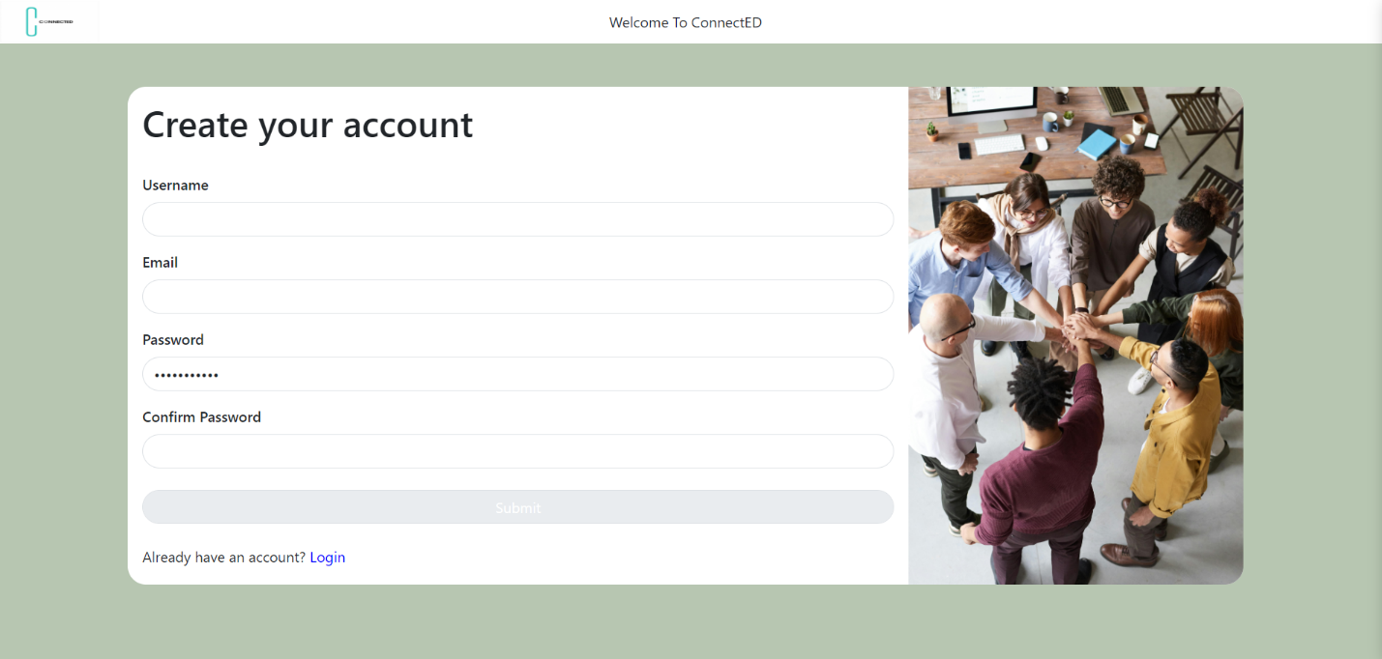

Wireframe:

